**PROJECT BEST DELIVERIES**

**Date: 24.12.2020**

**Deadline : Two months (Alpha version should be delivered to the customer)**

**Short description:**

The web app which is to deliver all in one app. The things such as Food, Medicine, Groceries, Stationaries, Money, Home needs which are needed by the customers are delivered by using this app.

**Outcome:**

Outcome of this project is to satisfy the customer and also the same time reduce the work burden of the admin.

**Modules:**

**Three Modules**

* **Customer side module**
* **Admin module**
* **Delivery partner module**

**Client’s requirement:**

**NEED TO GET FROM THE CLIENT ON THE FIRST MEETING**

**Color of the app:**

* **Red**
* **Yellow**
* **White**

**Technology using:**

**Front End**

* **Bootstrap**
* **Redux**
* **HTML,CSS**
* **Reactjs**

**Back End**

* **Node.js**
* **JAVA**

**Database**

* **MongoDB**

**Cloud**

* **AWS**
* **GoDaddy**

**TABLE OF CONTENTS**

**1. Introduction**

1.1 Purpose

1.2 Document Conventions

1.3 Project Scope

**2. Overall Description**

2.1 Product perspective

2.2 Product Features

2.3 User Classes and Characteristics

2.4 Operating Environment

2.5 Design and Implementation Constraints

2.6 Assumptions and Dependencies

**3. System Features**

3.1 Functional Requirements

**4. External Interface Requirements**

4.1 User Interfaces

4.2 Hardware Interfaces

4.3 Software Interfaces

4.4 Communication Interfaces

**5. Nonfunctional Requirements**

5.1 Performance Requirements

5.2 Safety Requirements

**1. INTRODUCTION**

**1.1 PURPOSE**

The purpose of this document is to build an online web application to deliver the customer needs in the all in one app. Also outcome of the project document is to reduce the work burden of the admin and automate the work activities which is done by him.

**1.2 DOCUMENT CONVENTIONS**

This document uses the following conventions

* Entity Relationship
* Database

**1.3 PROJECT SCOPE**

The purpose of the **Best deliveries system** is to ease the customer’s shopping process. The customer can make the orders whatever he wants by using this app. Once the customer makes the order that order will be placed at the admin’s system. The admin can assign the orders to the delivery partners based on his convenience. The delivery partners pick the orders and get them from the customer selected store, If the product is not available in that store then he can request customer to get the unavailable product from some another store. The delivery partner is traceable by the Customer as well as Admin.

**2.OVERALL DESCRIPTION**

**2.1 PRODUCT PERSPECTIVE**

* **Customer Module:**
* The customer should create his/her ID by username and a password
* The customer’s mobile should be verified by using an OTP
* After the successful login he can register his orders (The items and shop are shown at the customer’s side)
* After all the items selected he can place the order and make the payment by using GPay, Paytm which is embedded on the system or else he can make the payment by cash on delivery.
* The customer can trace the delivery partner while the order is on the way.
* He can receive the phone call from the delivery partner.
* After he received the orders he can rate the app.
* **Admin Module:**
* Admin can login by using his ID which is provided by the developers
* He can get the order which was placed by the customer
* Based on the admin’s convenience he can allocate the orders to the delivery partners
* Admin can track the delivery partners and the distance travelled by the delivery partners.
* Admin can get and update the documents from the delivery partners
* He can verify the payment is received from the customer
* Admin can add the store details and the product details on the page
* He can update the amount based on his convenience
* Admin can directly get the feedback from the customers
* Admin can place the offers if he wish.
* **Delivery Partner Module:**
* The app is given to the delivery partner
* He can login to the app on his working time
* He will submit the documents to the admin such as driving licence, Aadhaar, PAN, whatever admin wants.
* He gets the order from the admin
* He will purchase the items from the user selected shop.
* If the item is not available in the store then he can request the customer to get the order from some another store
* Finally he delivers the order to the customer and gets the payment from the customer.
* He can logout after his work time completed.

**SAMPLE WORKFLOW DIAGRAM**

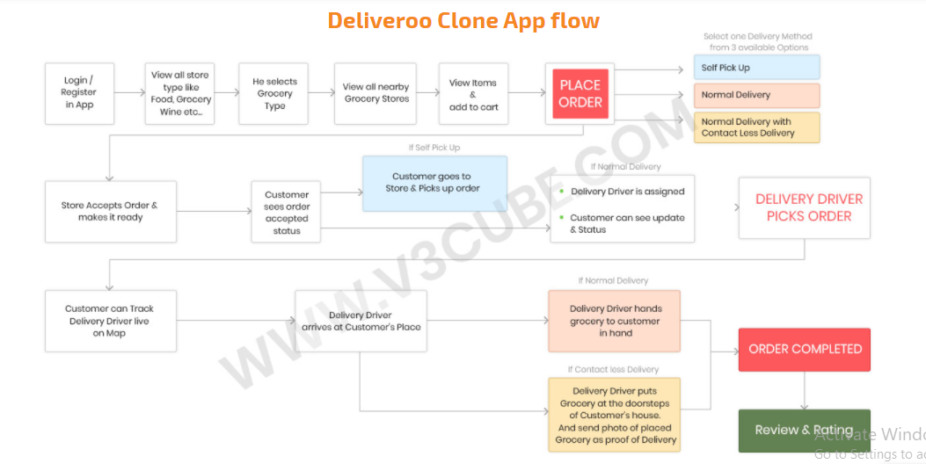

**SAMPLE SCREENSHOTS**

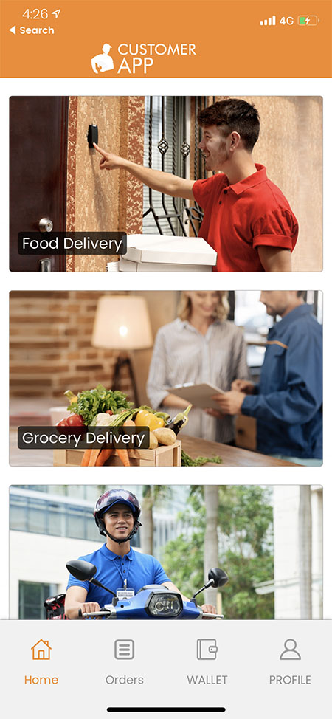

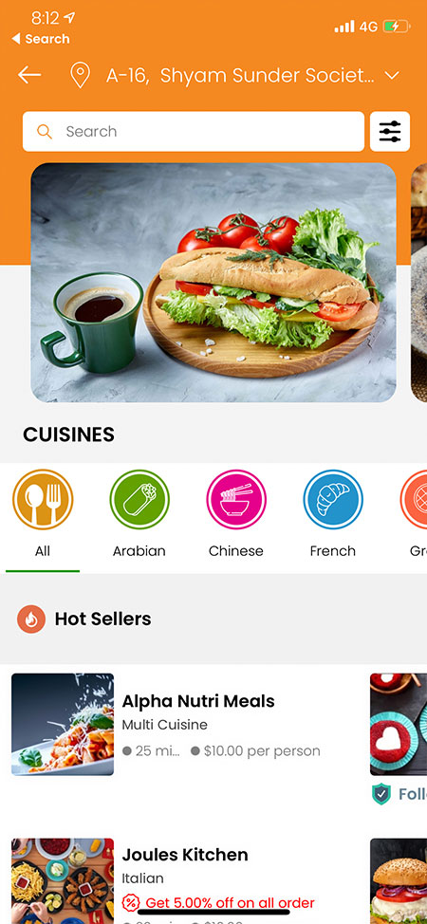 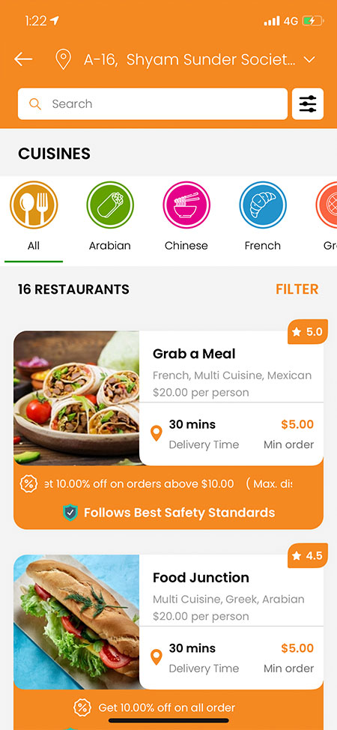

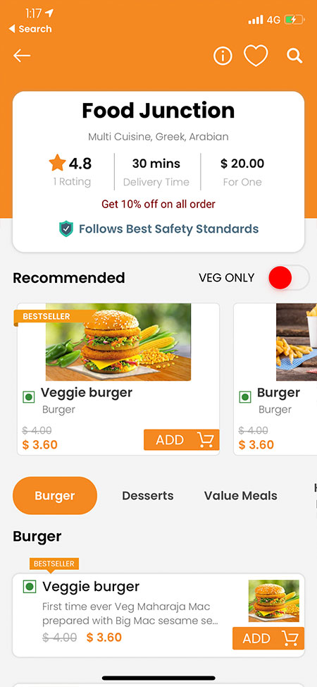 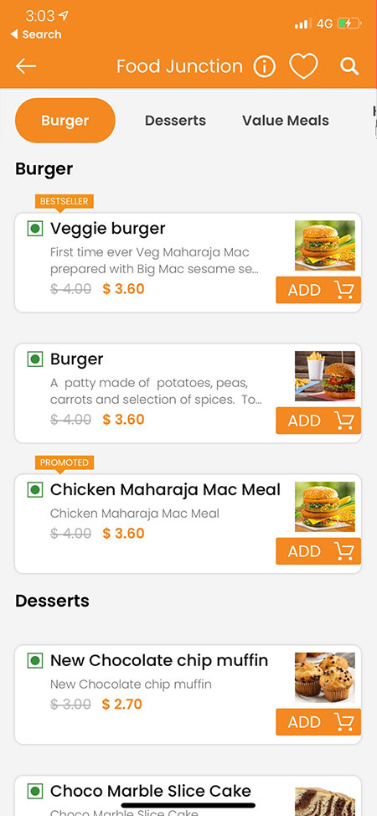

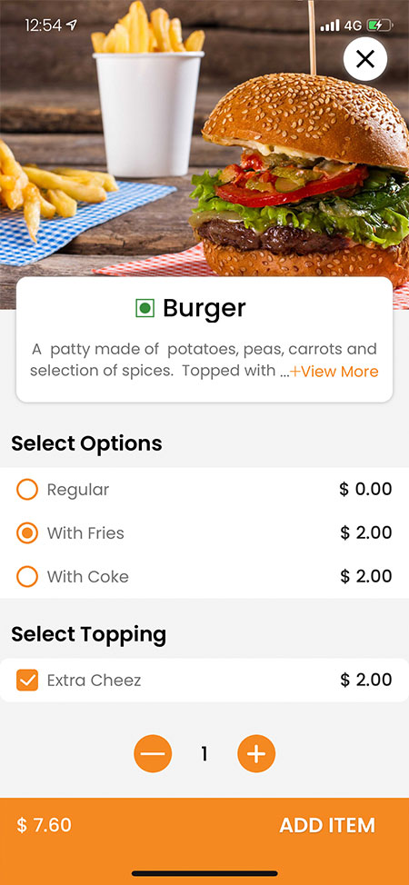 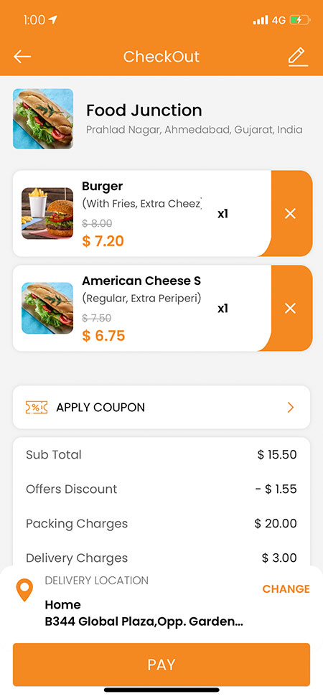

**ADMIN PANEL SAMPLE SCREENSHOT**



